For all pages
Top: large banner of DEI@WORK with ss department logo on top left (please use logos sent separately for higher resolution) and button to switch language (Chinese and English)
 (button text: 繁 / Eng)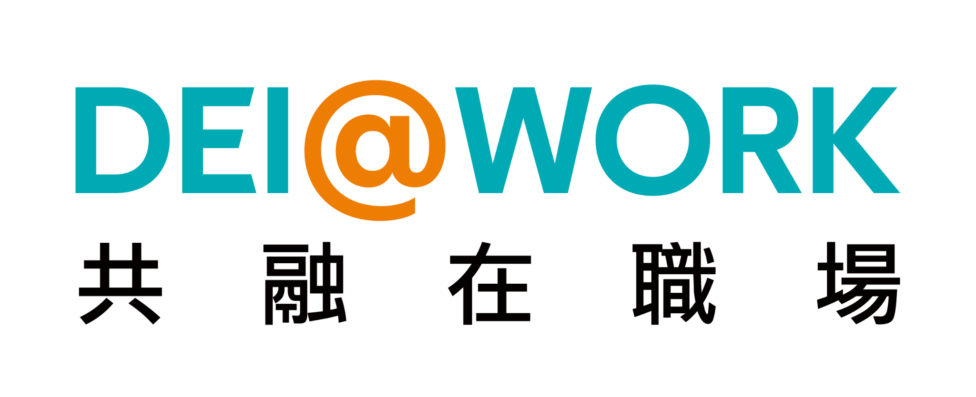
Tab panel (buttons to other tabs) (if possible, add FB and IG icon to link to our social media pages)
DEI@WORK facebook: https://www.facebook.com/profile.php?id=61557433298431&mibextid=ZbWKwL
Instagram: https://www.instagram.com/dei_at_work?igsh=MTMydGIxdGkzbXpz

Bottom: hyperlink to CityU website


Content:
both in Chinese and English (both versions same structure on different content)

Home Page
DEI@WORK Project
Initiator:
Prof. Ricky Kwan, Assistant Professor,
Department of Social and Behavioural Sciences

News
(see if you could input our IG page content here)

About Us
Our Aims

- Promoting Diversity, Equity and Inclusion (DEI) in the workplace​
- Enhancing awareness, empathy, and sensitivity towards diverse talents at work
- Promoting inclusion in enterprises and ensuring that individuals from all backgrounds have equal opportunities to thrive in the workplace through cooperation between NGOs, the business sector, and the academic sector.

Our objectives:

- To induce an appropriate attitude and awareness towards people with disabilities;
- To raise the awareness of NGO and enterprise managers and staff on appreciating the potentials about disabilities and the challenges that people with disabilities and diverse backgrounds face in the workplace;
- To equip managers and staff with the necessary knowledge and practical skills to work more confidently with and serve people with disabilities, and to aid helping professionals to provide inclusive services;
- To promote empathy and sensitivity towards people with disabilities, creating a more diverse and inclusive workplace culture; and
- To foster an inclusive work setting for people with disabilities.

About Us -> Our Services (subtab)
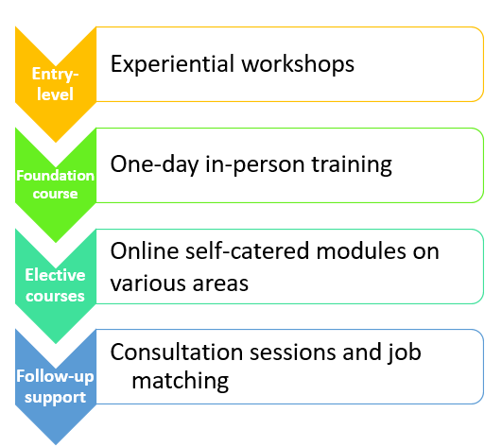(picture or interactive)

- Experiential workshops:
  - Skills workshops (e.g. Sign Language, Guiding people with visual impairment)
  - Human library sessions
  - Disability experience workshops
  - Other inclusive workshops (customizable)

- One-day courses introducing concepts and skills with interaction sharing, discussion and assessment
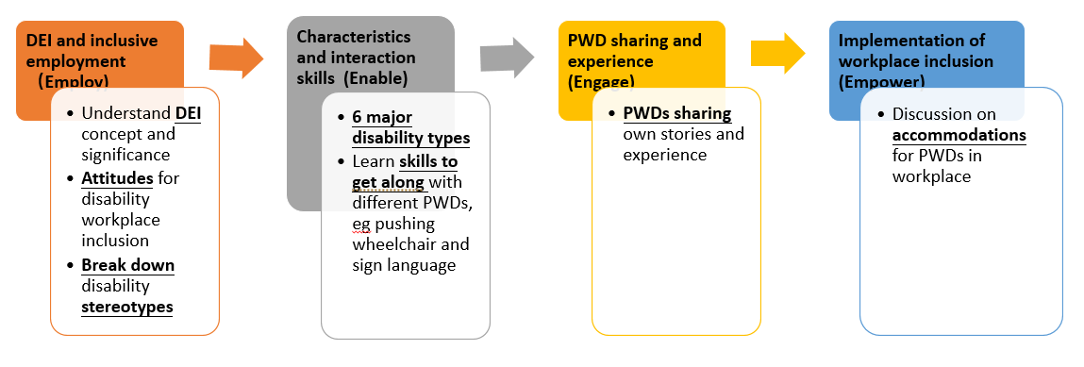(picture or interactive)
- Online courses with seven themes (see more at online resources) (hyperlink to online resources)
- Consultation and job matching referral to vocational rehabilitation services of NGOs

*Certificates will be issued for the completion of our one-day and 2 online courses of choice.

About Us -> Co-operating partners (subtab)

NGOs from eConnect Employment Network (In no particular order):
Baptist Oi Kwan Social Service
Hong Kong Blind Union
Hong Kong PHAB Association
The Hong Kong Society for the Deaf
Hong Kong Sheng Kung Hui Welfare Council
Richmond Fellowship of Hong Kong
SideBySide
The Hong Kong Society of Rehabilitation

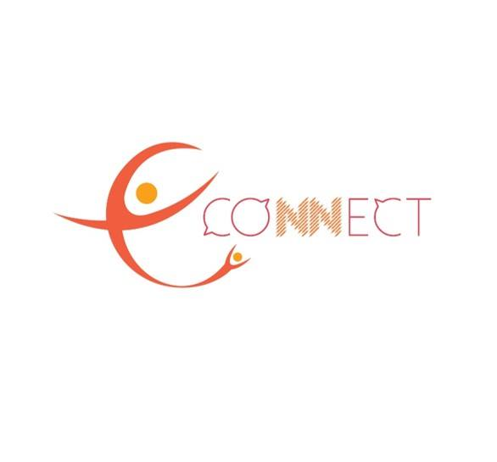(picture)

What is DEI
D stands for Diversity;
E stands for Equity;
I stands for Inclusion
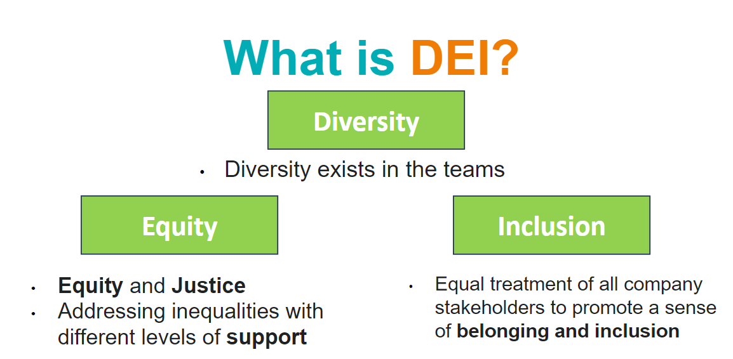(picture or interactive)

Media coverage
(please use the article title for the hyperlink show text)
05/06/2024 https://paper.hket.com/article/3770403?r=cpstni

24/05/2024 https://www.bastillepost.com/hongkong/article/14068210-deiwork%e5%8a%a9%e4%bc%81%e6%a5%ad%e5%af%a6%e7%8f%be%e5%82%b7%e5%81%a5%e5%85%b1%e8%9e%8d%e5%b7%a5%e4%bd%9c%e9%96%93

22/05/2024 https://www.am730.com.hk/本地/曾體會身心困苦-願聘用殘疾培訓技能-共融餐廳-當我哋跳板亦無任歡迎/454658

22/05/2024 https://www.52hrtt.com/mobileview/info?id=A1715823769902&areaId=120&behaviorSource=4&languageId=1&flag=1

21/05/2024 https://apps.orangenews.hk/app/common/details_html?contentId=1222410&fbclid=PAZXh0bgNhZW0CMTEAAaZHXHDVfb-elzuxqacSJET7kwdKqMLER-dW5HMy-WVNKzaLi2ZtfPwIeJ8_aem_AQjrlLMez3EKJ5CF--KkNzo2jzWMU3zCuDDuXK679SDVNSdilDhjnwMdwtqLXan-gE4t_cHlESh-51ZbQXi-KMAE

Online resources (new tab)
- We provide online self-catered modules on various areas​ of workplace inclusion
- Themes include:
- Working potentials and options for People with Disabilities
- Disability Etiquette
- Accessibility and universal design
- Assistive technology
- Inclusive management and supervision
- Mental health and disability
- Law and policy considerations​
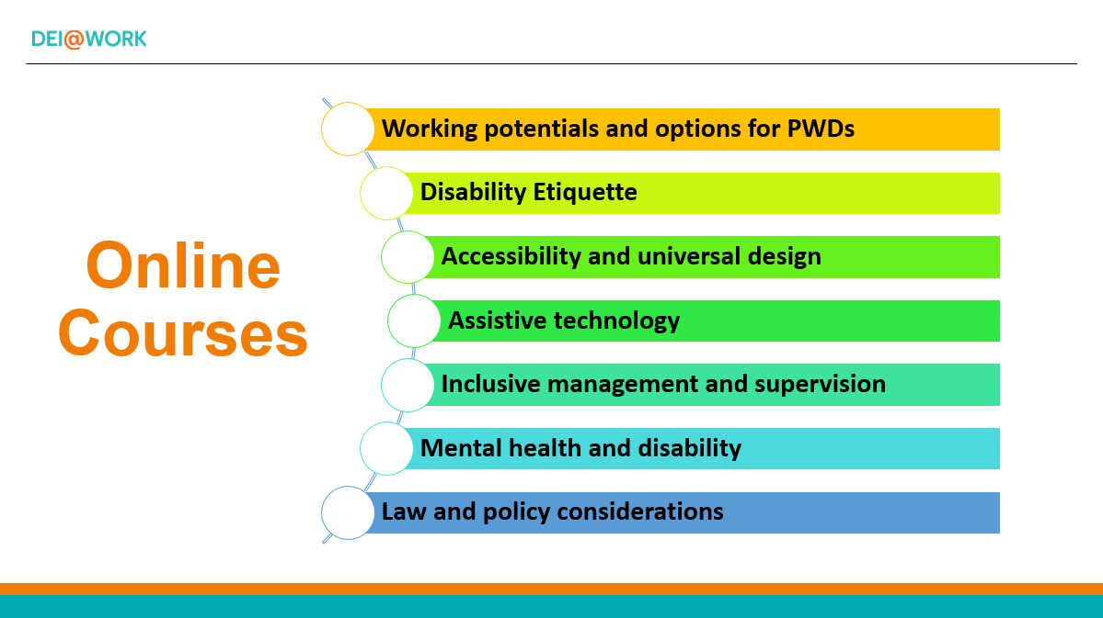
(picture or interactive)

Contact Us
Individuals/organizations/enterprises who are interested in having training or doing research related to DEI in workplaces, please contact us at:
Email: deiatworkplace@gmail.com
Address: Department of Social and Behavioural Sciences, City University of Hong Kong, 83 Tat Chee Avenue Kowloon, Hong Kong
At DEI@WORK website, we are committed to maintaining the trust and confidence of all visitors to our web site. In particular, we want you to know that DEI@WORK website is not in the business of selling, renting or trading email lists with other companies and businesses for marketing purposes.
In this Privacy Policy, we’ve provided detailed information on when and why we collect personal information, how we use it, the limited conditions under which we may disclose it to others, and how we keep it secure.
We take your privacy seriously and take measures to provide all visitors and users of DEI@WORK website with a safe and secure environment.
DEI@WORK website may set and access DEI@WORK website cookies on your computer. Cookies are used to provide our system with the basic information to provide the services you are requesting. Cookies can be cleared at any time from your internet browser settings.
When someone visits DEI@WORK website, there may be an ability to submit comments on particular articles or pages. When comments are submitted, you are entitled to use aliases or information that completely hides your identity. When a comment is submitted, the relevant details (name, email, website) that you provide are stored. These details are stored so that we can display your comment back to you, and to anyone viewing the comment sections on the site. We do not verify information entered nor do we require verification.
There may be some circumstances where your IP address, geographic location, and other browser related details may be shared with third party companies. We may share your above mentioned data with following third party companies from time to time.
You are entitled to view, amend, or delete the personal information that we hold. Email your request to our data protection officer Ms Queenie Lai at kitylai7@cityu.edu.hk and we will work with you to remove any of your personal data we may have.
We may make changes to our Privacy Policy in the future, however, the most current version of the policy will govern our processing of your personal data and will always be available to you.
If we make a change to this policy that, in our sole discretion, is material, we will notify you by an update or email, where possible. By continuing to access or use our services, you agree to be bound to the terms of our Privacy Policy.
(Bonus: Add FB and IG icon and link directly to our social media)

首頁
共融在職場
計劃發起人:
關志健教授，社會及行為科學系助理教授

最新消息
(IG page)

關於我們

計劃目的

- 推動職場多元、公平、共融。
- 提升不同界別人士在職場對殘疾人士的關注、同理、及敏銳度
- 透過「商、福、學」多界別合作，在企業推動共融，確保來自不同背景的人能享有平等機會，並能夠在職場發揮所長。

計劃目標

- 培養對多元人才的適當態度和認識；
- 提高非政府組織和企業管理人員和前線員工的共融意識，了解多元人才的潛力以及在工作場所面臨的挑戰；
- 為管理人員和專業工作員(如治療師、社工等)提供必要的知識和實踐技能，讓他們更有信心與多元人才一起工作，並提供考慮到不同群體需要的服務；
- 促進對多元人才的同理心和敏銳度，創造更多元化和包容的職場文化；和
- 為多元人才營造共融的工作環境。

關於我們 -> 我們的服務
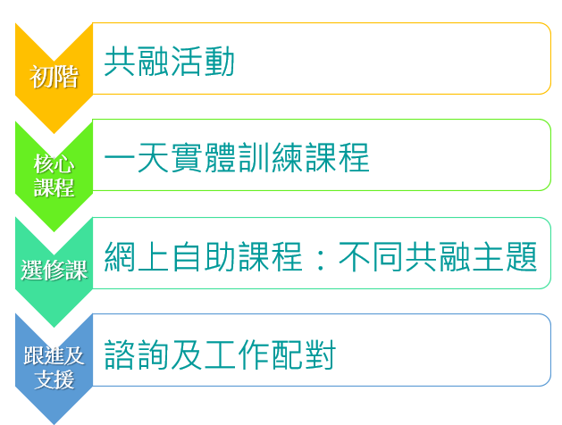
- 體驗式工作坊：
  - 技巧工作坊（例如手語、為視力障礙人士領路）
  - 真人圖書館
  - 殘疾體驗工作坊
  - 其他工作坊（可客製化）
- 一天殘疾就業共融基礎課程
  - 介紹共融概念
  - 認識相處技巧
  - 互動分享
  - 討論及實踐
  - 評估
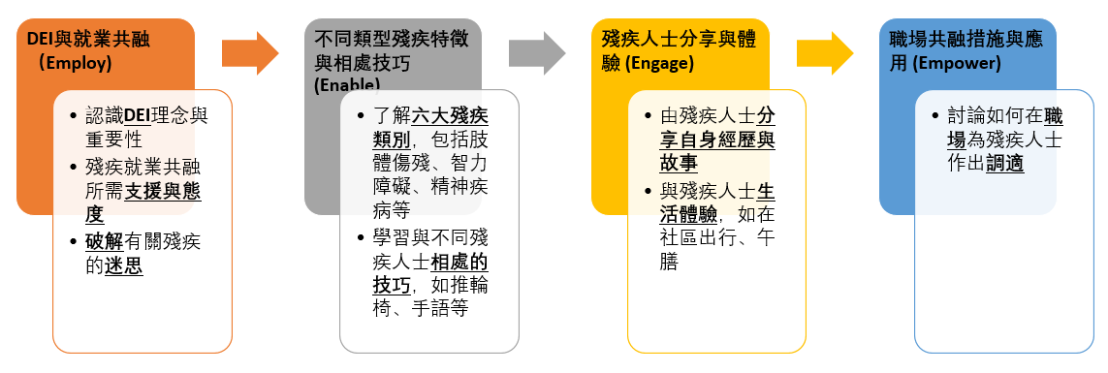
- 七個主題的線上課程（更多資訊請參閱網上資源）
- 非政府機構的職業康復服務諮詢和就業轉介

關於我們 -> 合作伙伴
eConnect 就業連網成員機構 (排名不分先後):
浸信會愛羣社會服務處
香港失明人協進會
香港傷健協會
香港聖公會福利協會
香港聾人福利促進會
利民會
善導會
香港復康會職業復康及再培訓中心


什麼是DEI
D代表多元 (Diversity)
E代表公平 (Equity)
I代表共融 (Inclusion)
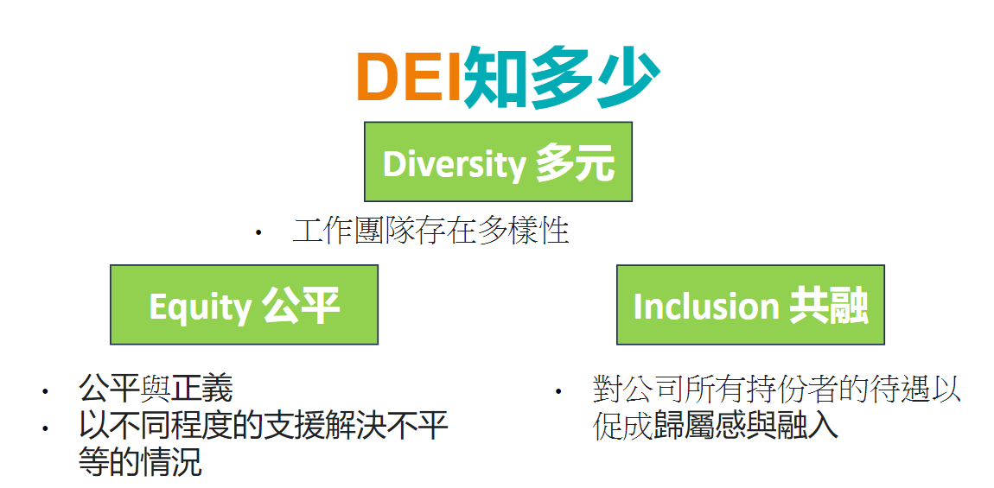

媒體報道
05/06/2024 https://paper.hket.com/article/3770403?r=cpstni

24/05/2024 https://www.bastillepost.com/hongkong/article/14068210-deiwork%e5%8a%a9%e4%bc%81%e6%a5%ad%e5%af%a6%e7%8f%be%e5%82%b7%e5%81%a5%e5%85%b1%e8%9e%8d%e5%b7%a5%e4%bd%9c%e9%96%93

22/05/2024 https://www.am730.com.hk/本地/曾體會身心困苦-願聘用殘疾培訓技能-共融餐廳-當我哋跳板亦無任歡迎/454658

22/05/2024 https://www.52hrtt.com/mobileview/info?id=A1715823769902&areaId=120&behaviorSource=4&languageId=1&flag=1

21/05/2024 https://apps.orangenews.hk/app/common/details_html?contentId=1222410&fbclid=PAZXh0bgNhZW0CMTEAAaZHXHDVfb-elzuxqacSJET7kwdKqMLER-dW5HMy-WVNKzaLi2ZtfPwIeJ8_aem_AQjrlLMez3EKJ5CF--KkNzo2jzWMU3zCuDDuXK679SDVNSdilDhjnwMdwtqLXan-gE4t_cHlESh-51ZbQXi-KMAE

網上資源
- 計劃提供涵蓋不同有關職場共融範疇的網上自學課程，供參加者因應自己時間及興趣選擇參與。
- 主題包括:
- 多元才能與工作機遇
- 共融相處禮儀
- 暢通易達及通用化設計
- 職場輔助科技
- 共融管治與督導
- 精神健康與共融
- 法律與共融政策

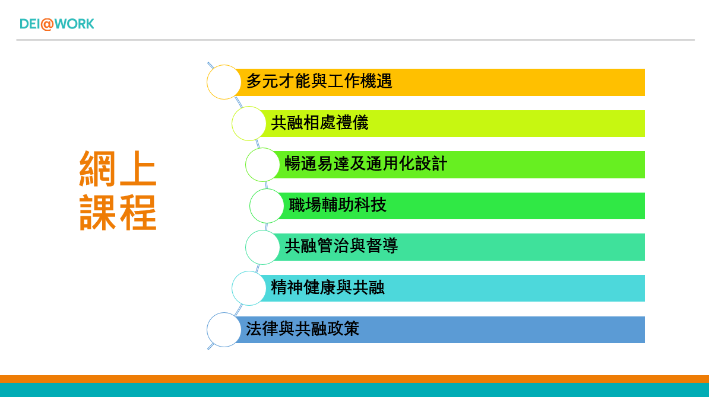

聯絡我們
個人/組織/企業如有興趣與本計劃合作推行共融在職場的培訓及研究，請聯絡
電郵: deiatworkplace@gmail.com
地址: 香港九龍塘達之路83號香港城市大學社會及行為科學系

非常歡迎您光臨「DEI@WORK 共融在職場網站」（以下簡稱本網站），為了讓您能夠安心的使用本網站的各項服務與資訊，特此向您說明本網站的隱私權保護政策，以保障您的權益，請您詳閱下列內容：
一、隱私權保護政策的適用範圍
隱私權保護政策內容，包括本網站如何處理在您使用網站服務時收集到的個人識別資料。隱私權保護政策不適用於本網站以外的相關連結網站，也不適用於非本網站所委託或參與管理的人員。
二、個人資料的蒐集、處理及利用方式
- 當您造訪本網站或使用本網站所提供之功能服務時，我們將視該服務功能性質，請您提供必要的個人資料，並在該特定目的範圍內處理及利用您的個人資料；非經您書面同意，本網站不會將個人資料用於其他用途。
- 本網站在您使用服務信箱、問卷調查等互動性功能時，會保留您所提供的姓名、電子郵件地址、聯絡方式及使用時間等。
- 於一般瀏覽時，伺服器會自行記錄相關行徑，包括您使用連線設備的 IP 位址、使用時間、使用的瀏覽器、瀏覽及點選資料記錄等，做為我們增進網站服務的參考依據，此記錄為內部應用，決不對外公佈。
- 為提供精確的服務，我們會將收集的問卷調查內容進行統計與分析，分析結果之統計數據或說明文字呈現，除供內部研究外，我們會視需要公佈統計數據及說明文字，但不涉及特定個人之資料。
- 您可以隨時向我們提出請求，以更正或刪除本網站所蒐集您錯誤或不完整的個人資料，請見最下方聯繫管道。
三、資料之保護
- 本網站主機均設有防火牆、防毒系統等相關的各項資訊安全設備及必要的安全防護措施，加以保護網站及您的個人資料採用嚴格的保護措施，只由經過授權的人員才能接觸您的個人資料，相關處理人員皆簽有保密合約，如有違反保密義務者，將會受到相關的法律處分。
- 如因業務需要有必要委託其他單位提供服務時，本網站亦會嚴格要求其遵守保密義務，並且採取必要檢查程序以確定其將確實遵守。
四、網站對外的相關連結
本網站的網頁提供其他網站的網路連結，您也可經由本網站所提供的連結，點選進入其他網站。但該連結網站不適用本網站的隱私權保護政策，您必須參考該連結網站中的隱私權保護政策。
五、與第三人共用個人資料之政策
本網站絕不會提供、交換、出租或出售任何您的個人資料給其他個人、團體、私人企業或公務機關，但有法律依據或合約義務者，不在此限。
前項但書之情形包括不限於：
- 經由您書面同意。
- 法律明文規定。
- 為免除您生命、身體、自由或財產上之危險。
- 與公務機關或學術研究機構合作，基於公共利益為統計或學術研究而有必要，且資料經過提供者處理或蒐集者依其揭露方式無從識別特定之當事人。
- 當您在網站的行為，違反服務條款或可能損害或妨礙網站與其他使用者權益或導致任何人遭受損害時，經網站管理單位研析揭露您的個人資料是為了辨識、聯絡或採取法律行動所必要者。
- 有利於您的權益。
- 本網站委託廠商協助蒐集、處理或利用您的個人資料時，將對委外廠商或個人善盡監督管理之責。
六、Cookie 之使用
為了提供您最佳的服務，本網站會在您的電腦中放置並取用我們的 Cookie，若您不願接受 Cookie 的寫入，您可在您使用的瀏覽器功能項中設定隱私權等級為高，即可拒絕 Cookie 的寫入，但可能會導致網站某些功能無法正常執行 。
七、隱私權保護政策之修正
本網站隱私權保護政策將因應需求隨時進行修正，修正後的條款將刊登於網站上。
八、聯繫管道
對於本站之隱私權政策有任何疑問，或者想提出變更、移除個人資料之請求，請前往本站「聯絡我們」頁面提交表單。

